FBI Background Check Instructions for UUCV Volunteers

- Go to https://www.identogo.com/locations/pennsylvania

- Click on “Digital Fingerprinting” on the left:

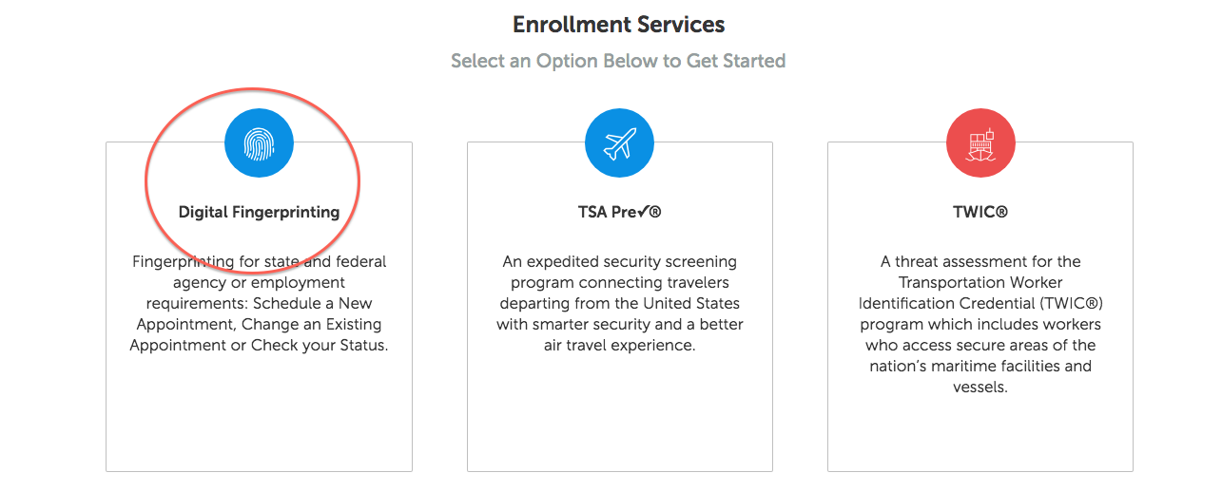

- Click on “FBI History Check”

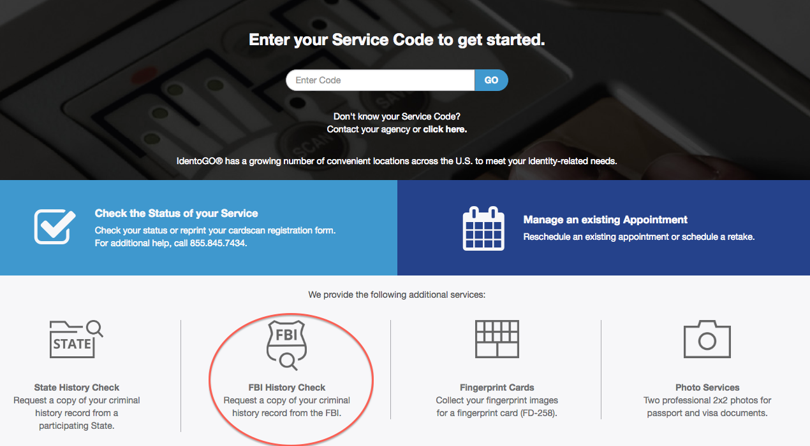

- Schedule an appointment. Enter your personal information.

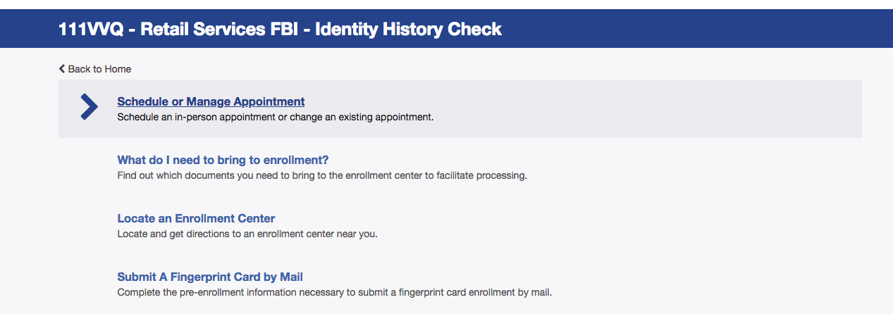

- When you get to “Reason for requesting an FBI Identity History Check,” select “Personal Review.”

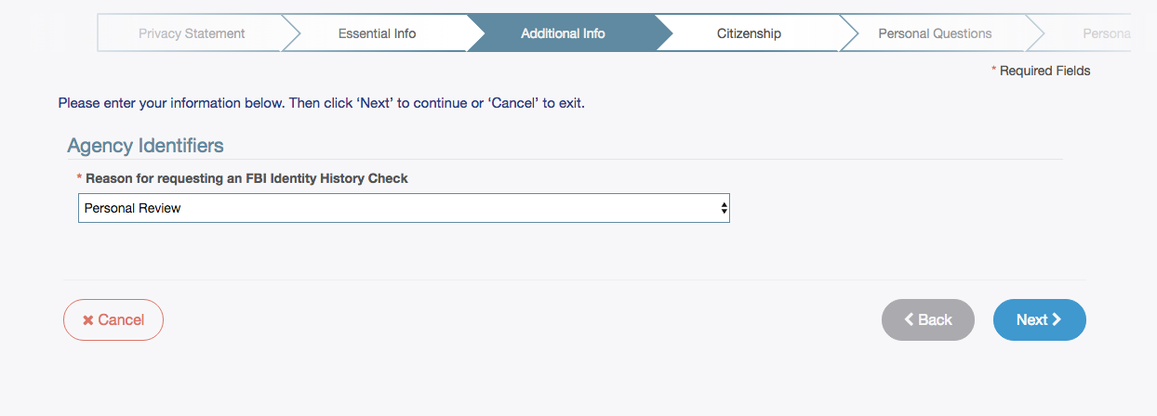

- Enter your Citizenship information.

- Answer the Personal Questions. Where it asks if you have an Authorization Code, select “No.”
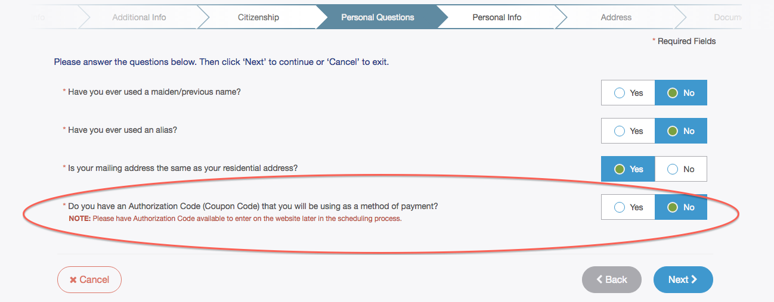
- Enter Personal Information.

- Enter your Mailing Address. This is where you will get your results.

- Select which document you will bring to your appointment. A PA Driver’s License or valid United States Passport will work.

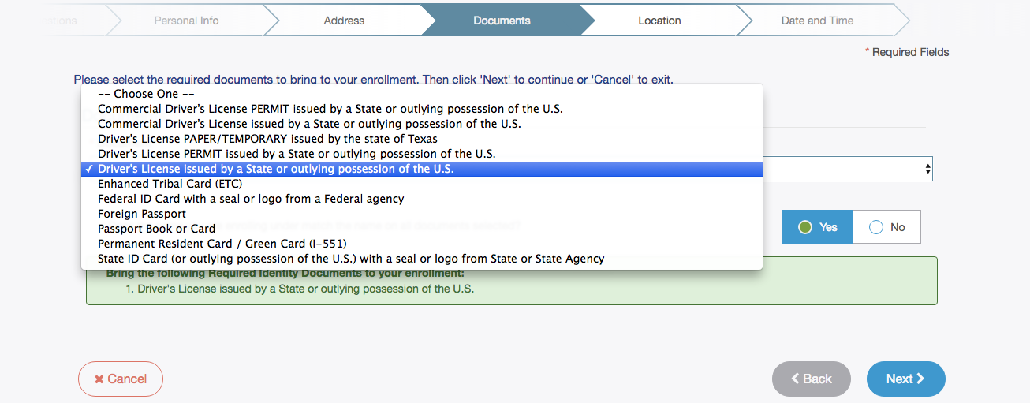

- Select an appointment location. If you enter “17013” you will see these results pop up. (The first address on High St. in Carlisle is Bosler Library)

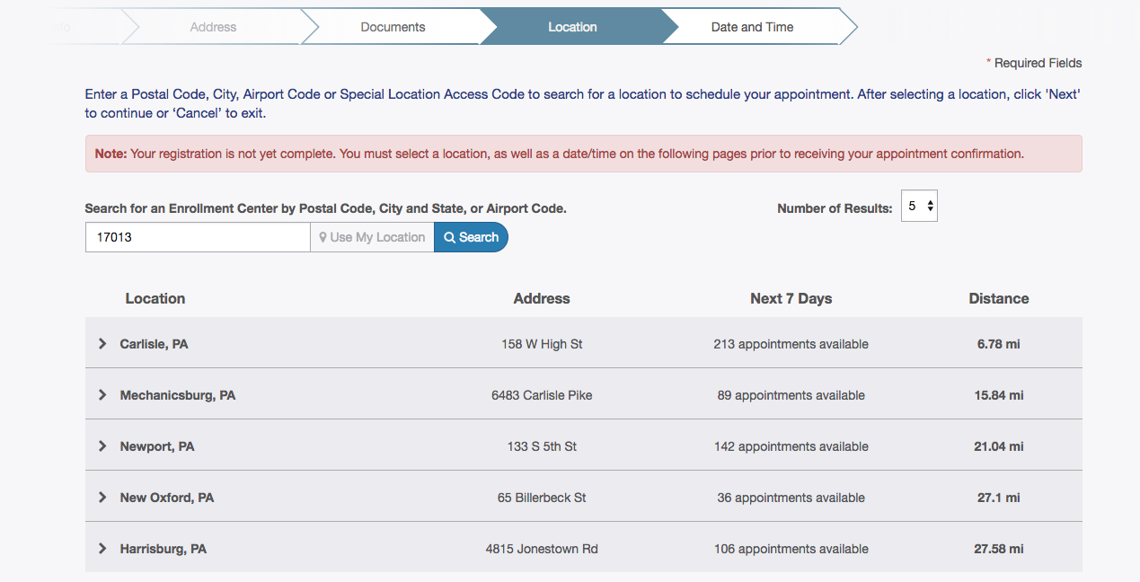

- Select an appointment date and time. (You can also select Walk In, but that might entail a wait).

- You should end on a confirmation page like this that lists your name, appointment time, location of appointment, etc. The service will cost $50, and they accept credit cards but NOT cash or personal check.

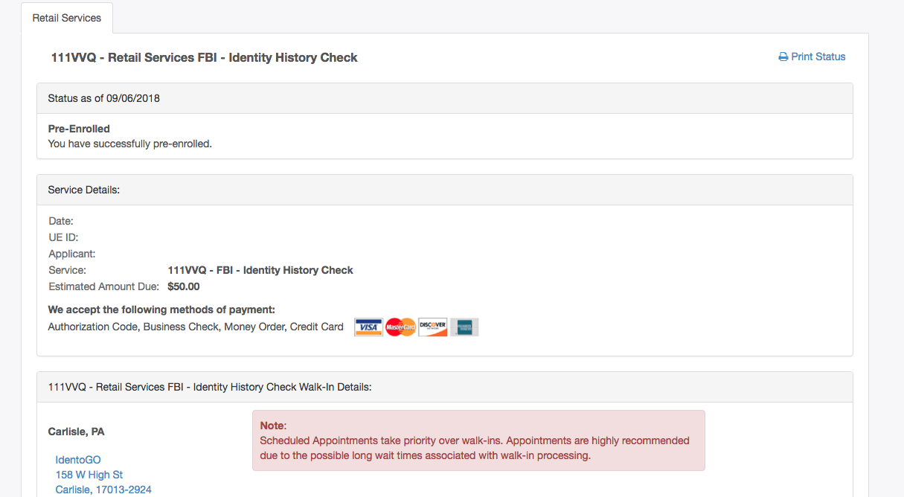

- This website has information about Bosler Library, including hours of service, what you need to bring to the appointment, parking information, etc.:
https://www.cumberlandcountylibraries.org/BOS_IdentoGO

- Go to your appointment. When you are finished they should give you a piece of paper with a confirmation number.

- You should receive results in the mail within two weeks. Bring the original copy to the Director of Lifespan Faith Development or Church Administrator.

